Project:
Discrete Structure

Member Names: Talha Abdullah Bangyal
Syed Hamza Saeed Kazmi

Roll Numbers: 22F-3194
22F-3112

Section: BS (AI)-3A
------------------------------------------------------------------------------
Question:
Take input of 2 sets each of at least three elements. Considering Cartesian. Product of the relation, find whether these relations exist or not. Also find the number of Relations.
1. The Total number of relations
2. Reflexive Relations
3. Symmetric Relations
4. Anti-Symmetric Relations
5. Both Reflexive and Symmetric Relations
6. Both symmetric and Anti-symmetric Relations

Problem:
#include<iostream>
using namespace std;
// Part 1: (Cartesian)
int Cartesian(int n1, int n2)
{
int size = 0;
for (int i = 0; i < n1; i++)
{
for (int j = 0; j < n2; j++)
{
size++; size++; // this is use to get number of relations
}
}
int n3 = size;
return n3;
}
// Part 2: (Reflexive)
void reflexive(int* arr1, int* arr2, int n1, int n2)
{
int Reflexivecheck = 0;
for (int i = 0; i < n1; i++)
{
for (int j = 0; j < n2; j++)
{
if (arr1[i] == arr2[j])
{
Reflexivecheck = 1;
break;
}
else {
Reflexivecheck = 0;
}
}
}
// checking reflexive relation
if (Reflexivecheck)
{
cout << "Relation is Reflexive." << endl;
}
else
{
cout << "Relation is not Reflxive." << endl;
}
}
// Part 3: (symmetric)
void symmetric(int* arr1, int* arr2, int n1, int n2)
{
int SymmetricCheck = 0;
for (int i = 0; i < n1; i++)
{
for (int j = 0; j < n2; j++)
{
if ((arr1[i] == arr2[j] && arr1[i + 1] == arr2[j + 1]) ||
(arr1[i] == arr2[j + 1] && arr1[i + 1] == arr2[j]))
{
SymmetricCheck = 1;
break;
}
else
{
SymmetricCheck = 0;
}
}
}
// checking symmetric relation
if (SymmetricCheck)
{
cout << "Relation is symmetric." << endl;
}
else
{
cout << "Relation is not symmetric." << endl;
}
}
// Part 4: (Anti-symmetric)
void antiSymmetric(int* arr1, int* arr2, int n1, int n2)
{
int AntiSymmetricCheck = 1;
for (int i = 0; i < n1; i++)
{
for (int j = 0; j < n2; j++)
{
if ((arr1[i] == arr2[j] && arr1[i + 1] == arr2[j + 1]) ||
(arr1[i] == arr2[j + 1] && arr1[i + 1] == arr2[j]))
{
AntiSymmetricCheck = 0;
break;
}
}
}
// checking antisymmetric relation
if (AntiSymmetricCheck)
{
cout << "Relation is anti-symmetric." << endl;
}
else
{
cout << "Relation is not anti-symmetric." << endl;
}
}
// Part 5: (Displaying a Cartesian product)
void display(int* arr1, int* arr2, int n1, int n2) {
// use to display a relation
cout << "{";
for (int i = 0; i < n1; i++)
{
for (int j = 0; j < n2; j++)
{
cout << "(" << arr1[i] << "," << arr2[j] << ") ,";
}
}
cout << "}" << endl;
}
// Main runner code
void start()
{
// declareing and initializing a variables
char count;
int size1 = 0, size2 = 0, size3 = 0;
int* arr1 = nullptr;
int* arr2 = nullptr;
do
{
// Menu through which user can select and get a specific task
cout << "------------------Menu--------------------" << endl;
cout << "Press 1 to make a Cartesian product" << endl;
cout << "Press 2 to check the total number of relations" << endl;
cout << "Press 3 to check a Reflexive relation" << endl;
cout << "Press 4 to check a Symmetric relation" << endl;
cout << "Press 5 to check an Anti-Symmetric relation" << endl;
cout << "Press 6 to check both Reflexive and Symmetric relations" << endl;
cout << "Press 7 to check both Symmetric and Anti-Symmetric relations" << endl;
cout << "Press 0 to exit" << endl;
cout << "Enter a value: ";
cin >> count;
// use of switch case to go in a specific part
switch (count)
{
case '1':
//Entering the size of sets/array
cout << "Enter size of set 1: ";
cin >> size1;
cout << "Enter size of set 2: ";
cin >> size2;
// using this for to check that user enter a size of array above 0
if (size1 <= 0 || size2 <= 0)
{
cout << "Size of matrix must be greater than 0." << endl;
break;
}
//Creating DMA (Dynamic memory allocation)
arr1 = new int[size1];
arr2 = new int[size2];
//Enter the values of sets/array
cout << "Enter values of set 1: ";
for (int i = 0; i < size1; i++)
{
cin >> arr1[i];
}
cout << "Enter values of set 2: ";
for (int j = 0; j < size2; j++)
{
cin >> arr2[j];
}
// function call
display(arr1, arr2, size1, size2);
size3 = Cartesian(size1, size2);
break;
case '2':
system("CLS");
if (size1 == 0 || size2 == 0)
{
cout << "Relations not created. Please create relation first." << endl;
break;
}
cout << "Total number of relations are: " << size3 / 2 << endl;
cout << "Cartesion product is: " << endl;
// function call
display(arr1, arr2, size1, size2);
break;

case '3':
system("CLS");
if (size1 == 0 || size2 == 0)
{
cout << "Relations not created. Please create relation first." << endl;
break;
}
cout << "Cartesion product is: " << endl;
// function call
display(arr1, arr2, size1, size2);
reflexive(arr1, arr2, size1, size1);
break;
case '4':
system("CLS");
if (size1 == 0 || size2 == 0)
{
cout << "Relations not created. Please create relation first." << endl;
break;
}
cout << "Cartesion product is: " << endl;
// function call
display(arr1, arr2, size1, size2);
symmetric(arr1, arr2, size1, size2);
break;
case '5':
system("CLS");
if (size1 == 0 || size2 == 0)
{
cout << "Relations not created. Please create relation first." << endl;
break;
}
cout << "Cartesion product is: " << endl;
// function call
display(arr1, arr2, size1, size2);
antiSymmetric(arr1, arr2, size1, size2);
break;
case '6':
system("CLS");
if (size1 == 0 || size2 == 0)
{
cout << "Relations not created. Please create relation first." << endl;
break;
}
cout << "Cartesion product is: " << endl;
// function call
display(arr1, arr2, size1, size2);
reflexive(arr1, arr2, size1, size1);
symmetric(arr1, arr2, size1, size2);
break;
case '7':
system("CLS");
if (size1 == 0 || size2 == 0)
{
cout << "Relations not created. Please create relation first." << endl;
break;
}
cout << "Cartesion product is: " << endl;
// function call
display(arr1, arr2, size1, size2);
symmetric(arr1, arr2, size1, size2);
antiSymmetric(arr1, arr2, size1, size2);
break;
case '0':
break;
default:
cout << "Are you Mad, you entered a wrong value!!" << endl;
break;
}
} while (count != '0');
delete[] arr1;
delete[] arr2;
}
//main fucntion
int main() {
start();
return 0;
}
Outputs:
Caption: In this code characters and floating numbers can generate an error.
Step 1: Open-Source code
Step 2: Run the code.
Step 3: Output will be shown on console.
Step 4: Press 1 to make a cartesian matrix.
Step 5: Enter size and values in each matrix.
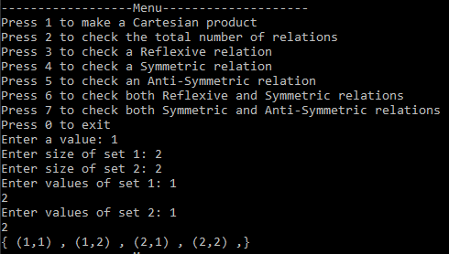
Step 6: Press 2 to get the number of Relations.
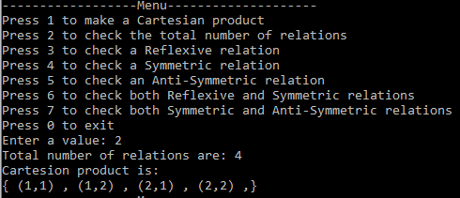
Step 7: Press 3 to get the Reflexive Relation.
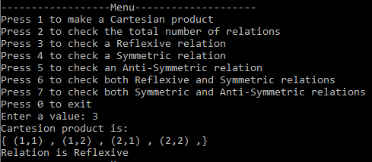
Step 8: Press 4 to get the Symmetric Relation.
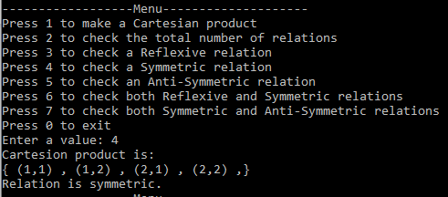
Step 9: Press 5 to get the Anti-Symmetric Relation.
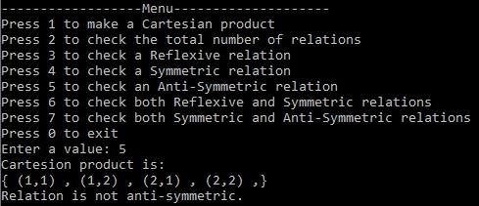
Step 10: Press 6 to get the Reflexive and Symmetric Relation.
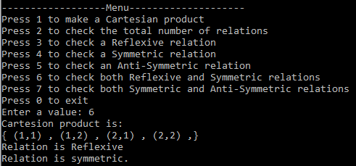
Step 11: Press 7 to get the Anti-Symmetric and Symmetric Relation.
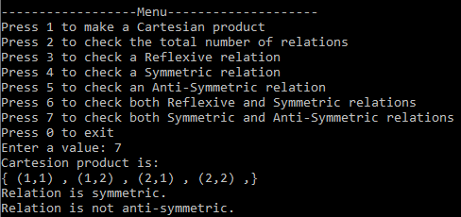
Step 12: Press 0 to close the program.
